2.68: One convenient way to do the problem is to do part (b) first; the time spent accelerating from rest to the maximum speed is 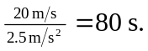
At this time, the officer is
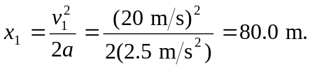

This could also be found from 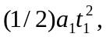 where t₁ is the time found for the acceleration. At this time the car has moved (15 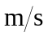)(8.0 s) = 120 m, so the officer is 40 m behind the car.

- The remaining distance to be covered is 300 m – x₁ and the average speed is (1/2)(v₁ + v₂) = 17.5 , so the time needed to slow down is

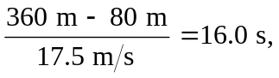
and the total time is 24.0 s.

c) The officer slows from 20 to 15 in 16.0 s (the time found in part (a)), so the acceleration is –0.31 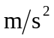.

d), e)

